*Rascal Propulsion Subsystem Overview*

Saint Louis University

Rascal



Last Updated: 5/7/14

Document No: RCL-O-PRP1

|  |  |  |  |
| --- | --- | --- | --- |
| Prepared by: |  |  |  |
|  | Tyler Olson  Rascal Propulsion Subsystem Team Lead |  | Date |
|  |  |  |  |
|  | Nick Mercadante  Rascal Propulsion Subsystem Engineer |  | Date |
| Approval: |  |  |  |
|  | Dr. Michael Swartwout  Rascal Principal Investigator |  | Date |

**Revisions Summary**

|  |  |  |  |  |
| --- | --- | --- | --- | --- |
| Revision | Description | Date | Prepared by | Approved by |
| 0 | Initial Release | 4/22/2014 | Tyler Olson | Tom Moline |
| 1 | Updated Delta V requirements | 5/06/2014 | Tyler Olson | Tom Moline |
|  |  |  |  |  |
|  |  |  |  |  |
|  |  |  |  |  |
|  |  |  |  |  |

Table of Contents

2. Introduction 4

2.1 Background 4

2.2 Purpose 4

3. Subsystem Overview 4

3.1 Major Requirements 4

3.2 Secondary Requirements 4

3.3 Current Design 4

3.4 Physical and Performance Characteristics 8

3.5 Status on Completed Work 8

4. Appendix 9

4.1 Lee EPSV Two-Way Solenoid Valves 9

# Introduction

## 2.1 Background

This document outlines the Propulsion (PRP) subsystem for the primary spacecraft of the Rascal mission.

## Purpose

The PRP subsystem will execute orbital translation maneuvers under the direction of the Colony-II GNC system. This will allow the primary spacecraft to rendezvous and maintain a stationkeeping distance with the secondary spacecraft.

# Subsystem Overview

## Major Requirements

From the RCL-RVM-CMQA1 Spacecraft Requirements Verification Matrix document, the PRP subsystem shall be responsible for fulfilling the following requirements:

RCL-RVM1-2-1: The primary spacecraft propulsion unit shall provide 3 degrees of freedom motion, as defined by the primary axes of its local coordinate frame.

RCL-RVM1-2-2: The primary spacecraft propulsion unit shall utilize a cold-gas propellant for all thrusting.

RCL-RVM1-2-3: The primary spacecraft propulsion unit shall provide a total ΔV capability of 50 m/s with a goal of 100 m/s.

RCL-RVM1-2-5: The total mass of the primary spacecraft’s propulsion system shall be no more than 75% of the payload mass, with a goal of 50%.

## Secondary Requirements

From the [insert document name here] document, the PRP subsystem shall be responsible for fulfilling the following requirements:

RCL-PL-PRP1: Pressure vessels shall have a factor of safety no less than 4.

RCL-PL-PRP2: Static thrust testing will be performed with the flight pressure vessel prior to CubeSat integration at a pressure no greater than 1*10^(-4) Torr.

RCL-PL-PRP3: The pressure vessel must pass thermal cycle testing between temperatures of -30°C and 70°C for a total of two cycles or 10 hours.

## Current Design

The current design utilizes R134-A as a propellant with the Lee EPSV two-way solenoid valves (see Appendix 4.1) and separates the propulsion unit into two 3d-printed components: a thruster assembly and a tank assembly. The tank’s maximum capacity is 0.2837 kg of liquid propellant (quality of 1) under 5.65 atmospheres of pressure.

In order to provide accurate translational control it is necessary to have the thrusters as close as possible to the spacecraft’s center of mass. This presents a challenge in that the interface between the Colony-II bus and the payload must then pass through the propulsion unit to connect, potentially increasing piping complexity and reducing tank capacity if the thruster and tank assemblies were structurally joined as a single unit. Separating the two assemblies circumvents this issue by placing the thruster assembly directly on top of the Colony-II bus and the tank assembly on top of the payload. The two assemblies are connected by a fuel line. Figure 1 shows a proposed layout of the primary spacecraft with the separated tank and thruster assemblies.

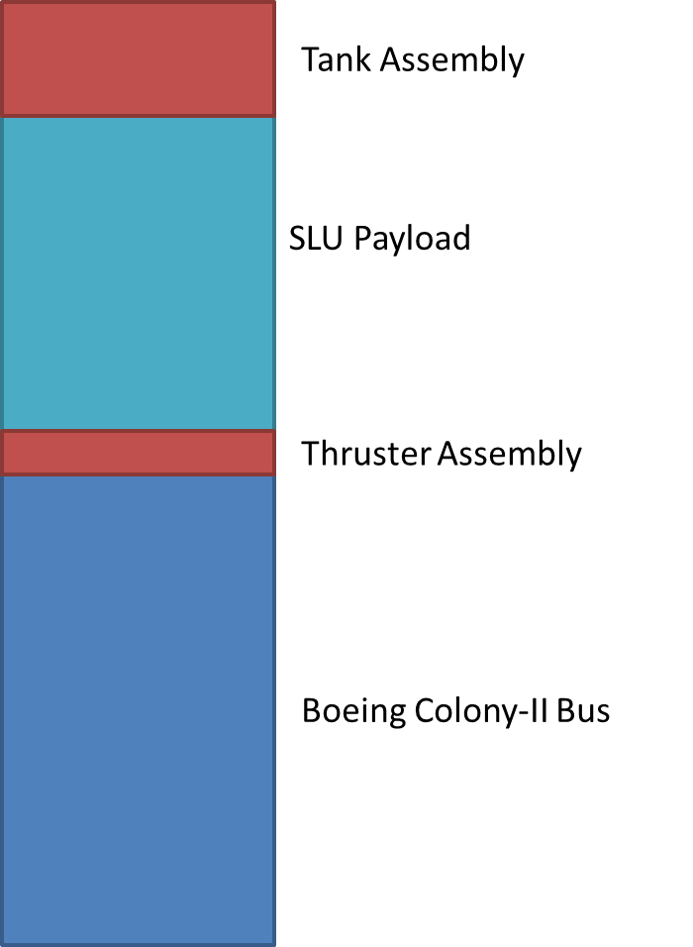

**Figure 1: Proposed Rascal Primary Spacecraft layout.**

The tank assembly consists of two major structures: the main tank and the expansion chamber. Assuming that the propellant is under high pressure, the expansion chamber ensures that the propellant is a gas before it reaches the thrusters. An expansion valve separates the main tank from the expansion chamber and a control valve isolates the tank assembly from the thruster assembly. Figure 2 shows a functional block diagram of the propulsion subsystem.

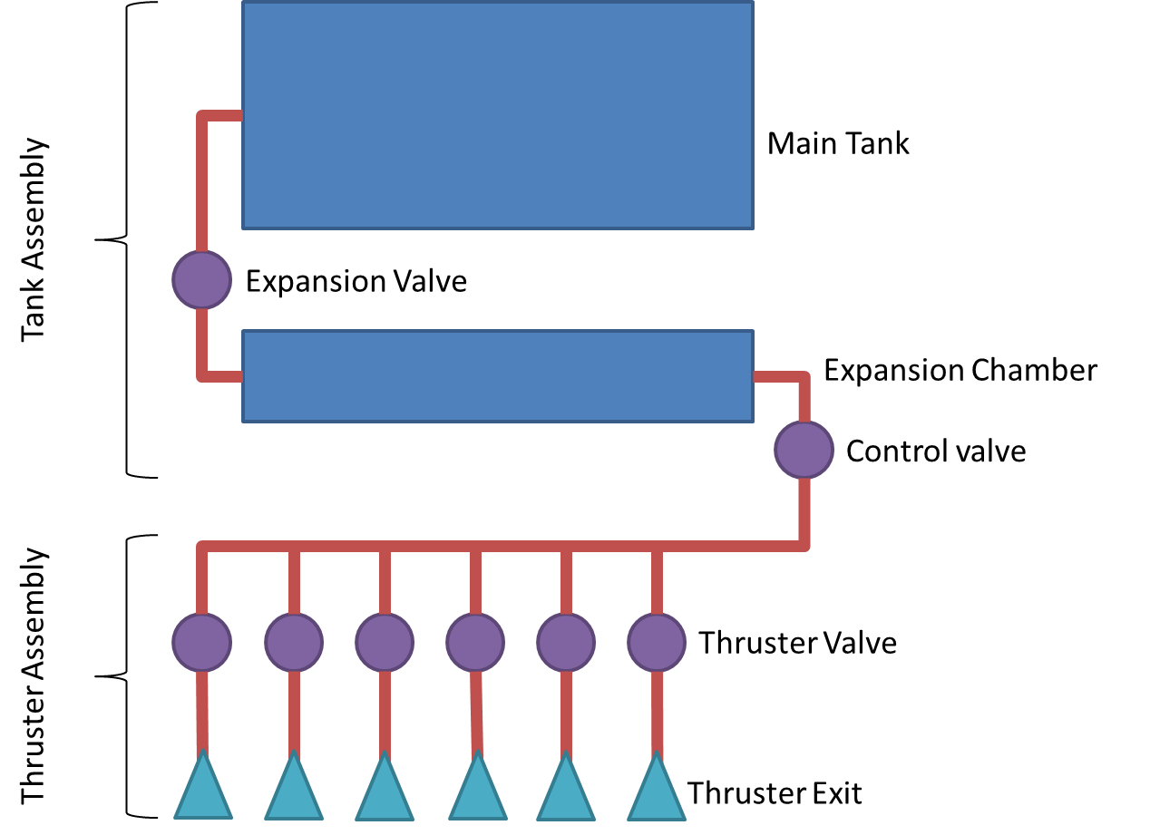

**Figure 2: Propulsion Subsystem Functional Block Diagram**

The thruster assembly consists of the six control valves, one for each direction of motion, connected to two thruster blocks and is compatible with the standard CubeSat bus. Each thruster block is flush with the spacecraft structure and has six thrusters, allowing for the required three degrees of freedom. Figure 3 shows the thruster placement on a thruster block, and Figure 4 shows the positioning of the thruster blocks on the 3U spacecraft.



**Figure 3: Thruster Block Detail**

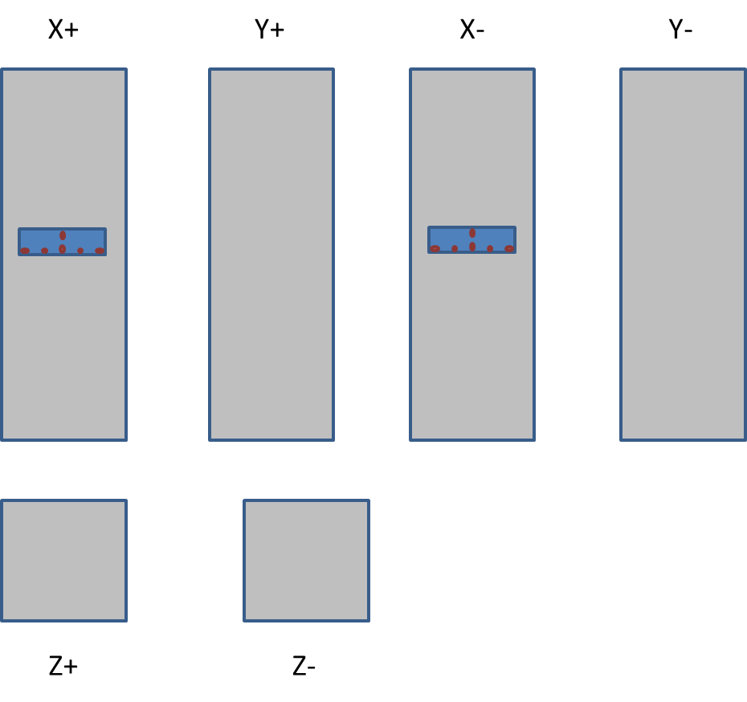

**Figure 4: Thruster Block Positioning**

Figures 5 and 6 show preliminary engineering drawings of the thruster and tank subassemblies, respectively. All measurements shown are in centimeters, and both subassemblies adhere to the CubeSat standard.

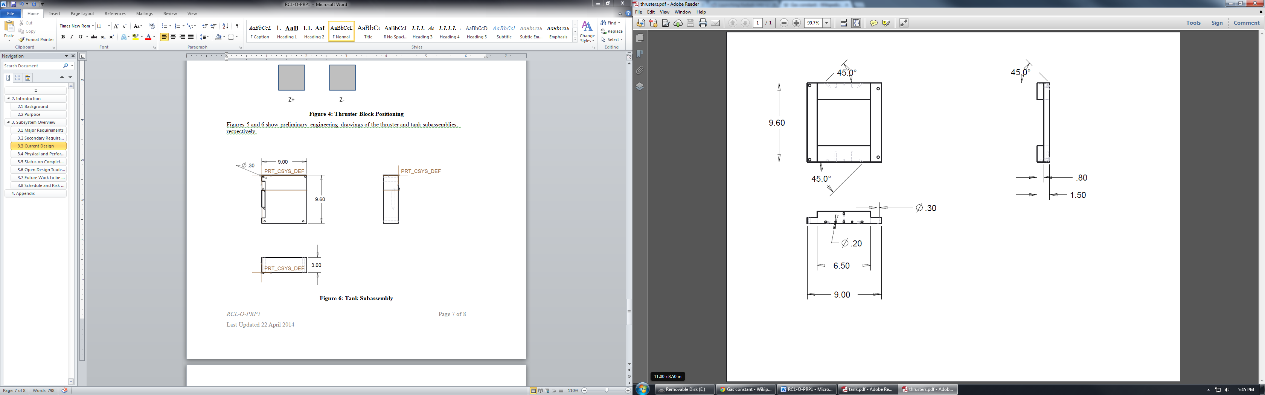

**Figure 5: Thruster Subassembly**

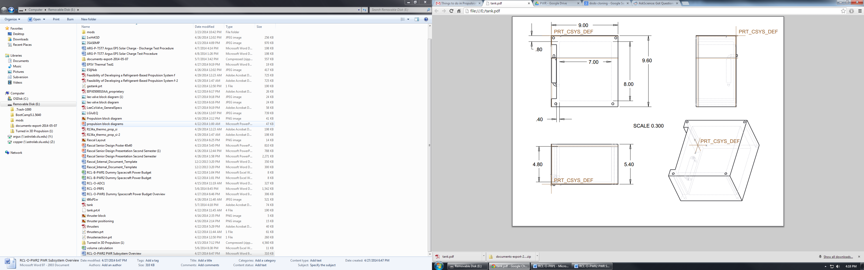

**Figure 6: Tank Subassembly**

## Physical and Performance Characteristics

The propulsion subsystem shall be designed to conform to the requirements proposed in the RCL-RVM-CMQA1 Spacecraft Requirements Verification Matrix and RCL-O-CMQA3 Concept of Operations document. These requirements were used to calculate the required mass of propellant and the corresponding propellant volume necessary to conduct the mission.

**Table 1: Propellant Calculations**

|  |  |  |  |  |  |  |  |
| --- | --- | --- | --- | --- | --- | --- | --- |
| Liquid Density  (kg / m^3) | Saturated vapor Pressure @ 20 °C (kPa) | Specific Impulse (s) | Required ΔV + 15% Margin (m/s) | Spacecraft Wet Mass (kg) | Spacecraft Dry Mass (kg) | Propellant Mass (kg) | Propellant Volume (cm^3) |
| 1150 | 572.10 | 48.50 | 35 | 4.00 | 3.71631 | 0.28369 | 246.69 |

# Appendix

## 4.1 Lee EPSV Two-Way Solenoid Valves

